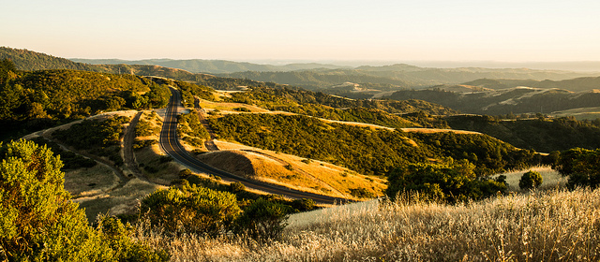Skyline Ridge Open Space Preserve
ES 3 class field trip, Saturday, May 18th 2019 1 - 4pm
bathroom parking lot @ 1:00pm
Directions:
East on McClellan Rd toward De Anza Blvd. .5 mi.
Right onto De Anza Blvd. 1.5 mi.
De Anza Blvd. becomes Saratoga/Sunnyvale Rd. 2.4 mi.
Right onto Big Basin Way/CA -hwy 9 continue to follow CA-hwy 9 7.3 mi.
Right onto Skyline Blvd. / CA- hwy 35 heading North 4.7 mi.
at stop sign @ four way intersection(if you start going downhill you've gone too far go back)
Skyline Ridge Open Space Preserve is on the left -- look for the sign I will have up for ES3 art session
- Give yourself about 40 minutes, the road is windy.
- pull into the entrance, turn right and park at restroom parking lot.
- We will be doing some hiking so come prepared and be on time.

What to bring:
- art supplies (sketchbook, pencils, erasers, sharpeners etc.)
- hat, layers of clothing jacket/windbreaker (never know what the weather will do) the wind can pick up in the afternoon
- good sturdy pair of shoes ie. tennis shoes or hiking shoes.
- water and snack
- pad or plastic to sit on

